Performance of Roof Top Grid Connected Solar Photovoltaic System
Tarana Afrin Chandel, Mohd Yusuf Yasin, Md Arifuddin Mallick
tarana@iul.ac.in, myyasin@iul.ac.in, mamallick@iul.ac.in

Abstract:
Solar Technology is a recent trend in the generation of electric power. Grid connected solar photovoltaic system is an affordable substitute for generation of electricity at a large scale. Such large power systems efficiently work under a grid. In this work a 150KW grid connected solar photovoltaic system is designed and modeled and is compared with real time data. Model used for real time data is RenewSys DESERV 3M6 72 Cells. It is a Multi Crystalline Silicon Module. In this paper we have studied the design aspect and the annual performance of solar photovoltaic power plant.

Key words: Electric Power Grid, Multi Crystalline Silicon PV Modules, Maximum PV Power, Solar Energy, Tilt for P_{max} in Lucknow
______________________________________________________________________________________

Corresponding Author: Tarana Afrin Chandel
Department of Electronics and Communication Engineering
Integral University,
Post Bas-ha, Kursi Road,
Lucknow, 226026, U.P
INDIA
Email: tarana@iul.ac.in
______________________________________________________________________________________

- Introduction

Solar energy is a fast growing field for electric power generation. It is perfectly eco friendly as the process of electric power generation simply involves photovoltaic effect and thus causes no environmental pollution. Renewable energy technologies (solar and wind energy) are fast replacing conventional energy technologies for the last decade. Renewable energy is directly related to the economic growth and pollution free environment of our country. [1], where-as non conventional energy sources have their own limitations such as they are limited, expensive, cause pollution and are responsible for global warming. Our research is based on solar energy. Solar photovoltaic (PV) modules are having 80% cost reduction than conventional energy sources. This data has been analyzed by International Renewable Energy Agency in 2009 [2]. The cost of generation of electricity form solar energy has reduced to one third in last decade and is constantly reducing. The motive of our study is to design solar photovoltaic system and to compare its performance. For this purpose, real time data of 150KW power plant installed on the roof top of new girl’s hostel of the Integral University. The material used in the module is a multi crystalline Silicon. It is a 320 watt module containing 72 cells. To generate 150KW, 460 modules are connected in series and parallel with 3 inverters of 50 KVA each. This model is designed and simulated on Matlab/Simulink with the help of standard module parameters, discussed below.
The main objectives to install 150 KWp to supply non-stop electricity in the campus with pollution free environment. It is also the biggest source to provide real time data for study. This study is done at Integral University, Lucknow, capital of Uttar Pradesh in India. According to map the standard latitude and longitude coordinates are 26°50'21.41"N, 80°55'23.27"E. The The Ministry of New & Renewable Energy has targeted solar power - ground mounted 10000 MWp and has achieved 24582 MWp as on 31 December 2018. Solar power - roof top target was 1000 MWp however, the achievement was reported 1443 MWp [3], with a 15º tilt to position the module w.r.t. ground. In this paper we have designed the model using MATLAB and the simulation result of the model is compared with the real time 150 KW solar power plant at the rooftop of our building.

1.1 Construction and Working Operation of Solar cell
Solar cell diode is different from conventional p-n junction diode. A thin layer of p-type semiconductor is fabricated on thick layer of n-type semiconductor. A thin electrode on top of p-type semiconductor allow light to pass through and reached p-type semiconductor as shown in figure1.
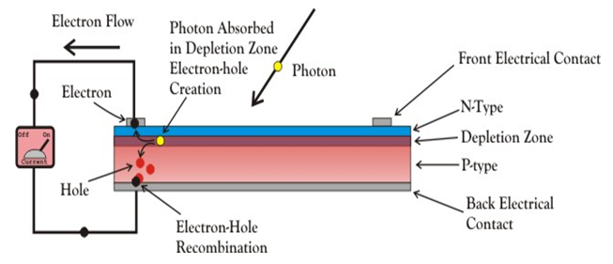
Figure1: Cross sectional view of solar cell diode
When sun’s rays fall on the p-n junction of the solar cell, photons on entering the junction, the thin p layer supply sufficient energy to the p-n junction thus generating electron-hole pair. The free electrons in the depletion region cross the junction and moves toward n-type, similarly holes in the depletion region cross the junction and moves towards p-type. Once, this happen, further movement of electrons and holes does not occur due to depleted potential barrier occurring between these two types of layers. When the concentration of electron and hole become higher on either side the p-n junction behaves as a battery [4]. When a load is connected across it, current flows through it. The I-V and P-V characteristic is shown in figure 2. During night, when there is no sun light, the solar cells are inactive. It simply behaves as p-n junction diode and remains connected to the external load, producing reverse saturation current or also called the dark current [5]
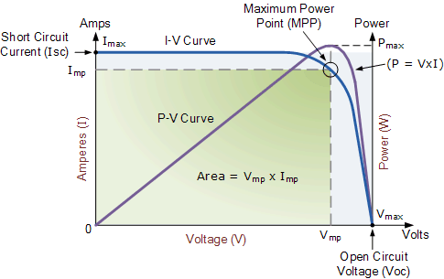
Figure 2: I-V and P-V characteristic of solar cell

- Designing and Modeling of the Solar Photovoltaic System
The model is designed in MATLAB /SIMULINK. For developing this model we have chosen Model RenewSys DESERV 3M6 72 Cells-320 Watt, manufactured by RenewSys. It is multi crystalline silicon module. It is a 150 Kw grid connected photovoltaic generation system, installed at the rooftop of our university building. RenewSys DESERV 3M6, 150KW power generation system consists of 460 modules with three inverters of 50KVA each.The solar photovoltaic system is designed using mathematical modeling using simulink. The design model of 150 KW solar photovoltaic power generation systems is shown in figure 3 and its internal architecture is shown in figure 4 The equation used to model the SPV system are mentioned while modeling the system [6].

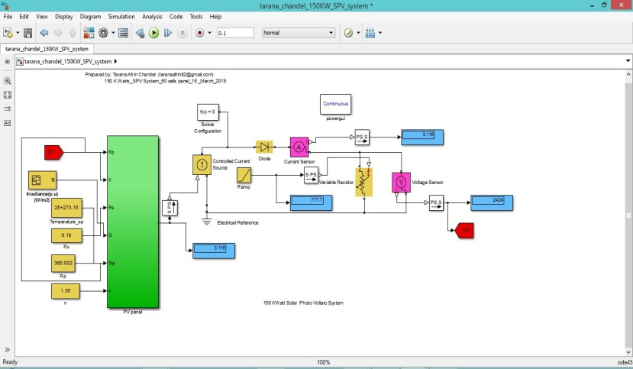

Figure 3: 150 KW SPV System

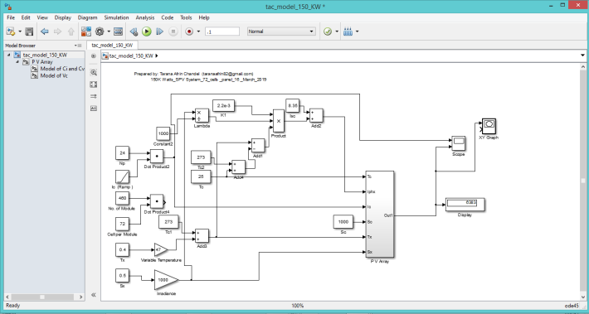

Figure 4: Internal architecture of 150 KW SPV System

The output current equation is given by
${I=I_{ph}.N_{p}-I_{d1}- I}_{sh}$ ………………………..(i)

$I=I_{ph}-I_{o}\left(e^{(\frac{V_{d}}{∝V_{t}})}-1\right)- \left[ \frac{\left(V+I R_{sh}\right)}{R_{sh}}\right]$………….. (ii)
The equation (i) shows that the total current at the load is the sum of photon current multiplied by the number of cells in parallel, the current across the diode and the current across the shunt resistance. The PV array has two sub-system consisting of model of V_{cell} (voltage across the cell) and model of I_{cell} (current across cell) which is shown in figure 5. It consists of model of V_{c} and model of Ic.

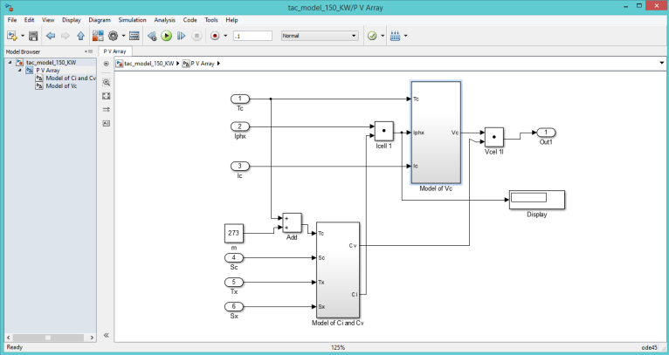
Figure 5: Model of subsystem of Photovoltaic Array
The internal architecture of the model V_{Cell} to get open circuit voltage (Voc) is shown in figure 6. The open circuit voltage is given by
$V_{oc}=\frac{m.k. t_{op} .N}{q}I_{n}(\frac{I_{ph}}{I_{o}})$ ……………….……. (iii)
$I_{ph}= G_{K}[I_{sc}+K_{I} \left(T_{op}- T_{ref}\right)]$ --------- (iv)

$V_{cell= } V_{oc }- I_{c }. R_{s}$ ………………………… (v).
where
$I_{sc}$ = Short circuit current (9.06 A)
K = Boltzmann Constant
$T_{op}$ = Operating value of temperature
$T_{ref}$ = Reference value of Temperature (25ºC)
$G_{K}$ = Solar irradiance ratio
N = No. of cells
$G_{K}$ = $\frac{G_{op}}{G_{ref}}$
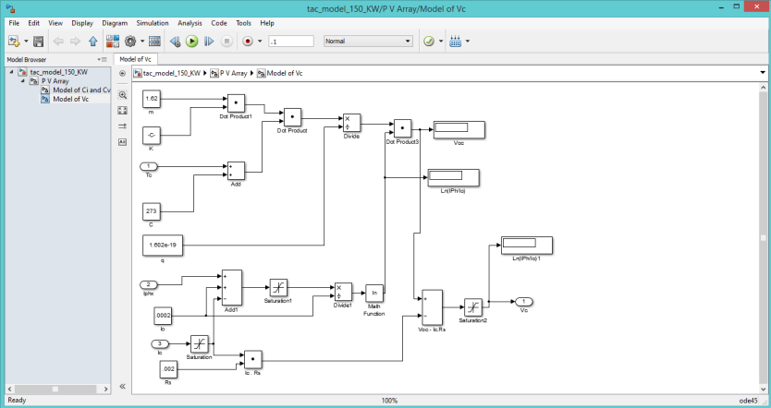
Figure 6: Model of V_{Cell}
The internal architecture of the model of cell current is shown in figure 7. In the given model we have taken alpha (α) as +0.50%/ °, beta as -0.30%/ °C and gamma as -0.40%/ °C the cell current is given as
$$I_{cell}=\frac{\left(T_{op}- T_{ref}\right)ϒ}{G_{k}}$$
and $I_{sc}= \frac{G_{op}}{G_{ref}}+ 1$, where $G_{op}$ is the actual irradiance and $G_{ref}$ is the nominal irradiance.

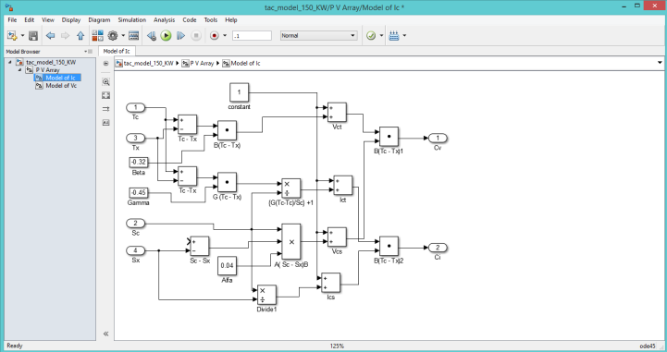
Figure 7: Model of I_{cell}
Table 1: Model DESERV 3M6-320
Performance under standard test conditions (1000w/m2 AM 1.5, 25º C)
Material | Multi Crystalline Silicon Modules
Electrical Parameters | STC 1000W/m2 | NOCT 800W/m2
Maximum power (Pmax) | 50W | 238.15 W
Voltage at Pmax (Vmpp) | 37.20 V | 34.02 V
Current at Pmax (Impp) | 8.61 A | 07.01 A
Short circuit current (Isc) | 9.06 A | 07.41 A
Open circuit voltage (Voc) | 46.18 V | 42.93 V
Module Efficiency % | 16.50
Cell Temperature Coefficient
Temperature coefficient of Isc ( Alpha) | +0.50%/ °C
Temperature coefficient of Voc – ( Beta) | -0.30%/ °C
Temperature coefficient of Pmax (Gamma) | -0.40%/ °C

52.8 modules were connected in series and 9 modules were connected in parallel. 52.8 modules signify that 53 modules are used in parallel but 1 module is under partial shading. It shows that 20 % of a single module is partially shaded. The SPV system is simulated using above mentioned electrical parameters shown in table 1. I-V characteristic and P-V Characteristic is shown in figure 8 and figure 9 respectively.
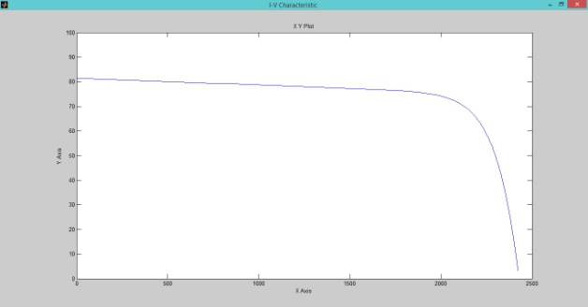 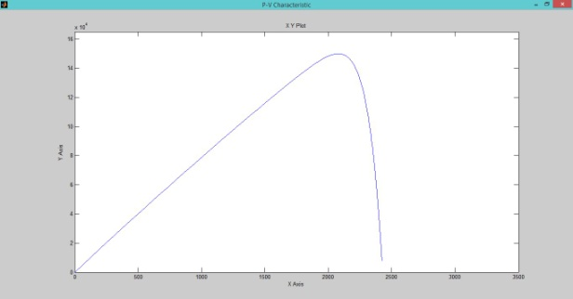 Figure 8: I-V Characteristic Figure 9: P-V Characteristic
Solar Photovoltaic System
The bock diagram of grid connected SPV system is shown in figure 10 where as figure 11 represent the block diagram of 150 KWH solar photovoltaic systems installed at new girl’s hostel, Integral University.

Figure 10: Block diagram of Grid connected SPV system
Figure 11, consist 460 numbers of PV modules, three converters, three DC/AC inverters each of 50 KVA, and a transformer. In this grid connected SPV system, batteries are not used. The electrical data of the panel is shown in table 1 in which power is320 watt, maximum voltage is 37.7 volt, maximum current is 8.5 ampere, open circuit voltage is 46.1 volt and short circuit current is 9.03 ampere with efficiency of 16.6 %.

Figure 11: Block diagram of 150 KW Grid connected SPV System

Photovoltaic Array
The photovoltaic semiconductor material when exposed to sunlight converts photon into recombination of electrons and holes thus generating electricity [7][8]. A single solar device is called a cell, when exposed to sunlight generate 1 or 2 watt power. These numbers if cells combine to form a module. The number of modules connected in series and parallel to form a photovoltaic array. The photo-voltaic module is a part of SPV system. System also require mounting structure with a tilt of 15º (Lucknow, India (26.75°N, 80.50°E)) pointing the panel towards the direction of the sun proving maximum energy and obtaining the highest return on investments [9].
Junction Box
The junction box is used in the power plant to connect all the output of wire from the modules to form single output that can be connected to the inverter. The junction box input connectors are single conductor pigtail that are wired to the PV modules and has a single output having two wires [10]. This junction box is installed as the safety fuse for each string and serves as a protector to the module. Solar module junction box is shown in figure 12.
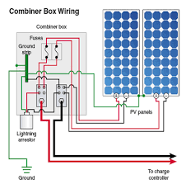
Figure 12: Solar module junction box
Inverter
An inverter is a device used to convert the direct current (DC) voltage source to an alternating current (AC) voltage source [11]. The AC output frequency of the inverter should be equal to the standard power line frequency which is 50 Hz for India. The power rating of an inverter is expressed in Watts or Kilowatts. To achieve the goal of power supply, a grid connected voltage source inverter is required to interface the power transfer [12]. Solar inverters can be used for on-grid and off grid connected systems. Solar inverters are specially used for maximum power point tracking. Grid-tied inverters transfer power synchronously with the line having minimum harmonics. Three phase inverter is shown in figure13
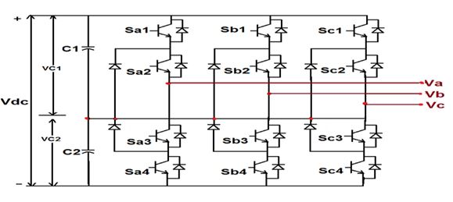
Figure 13: Three Phase inverter
Inverter efficiency is the ratio of AC power generated by the inverter to the DC power generated by the PV array system is called inverter efficiency. The inverter efficiency is given by,
$$ղ_{inv}= {P_{ac}}/{P_{dc}}$$
Transformer:
Transformer is a static device used to transfer an electrical energy from one source to another without any change in frequency by means of electromagnetic induction. This energy is transferred between the two sources through mutual induction of the two coils or Faraday Law’s of Electromagnetic induction. Due to flux link, the current in secondary coil changes when current in primary coil change. Therefore electromagnetic field is developed in secondary winding of transformer due to Faraday’s law. The transformer works on two basic principles. First is that the electric current in the winding produces a magnetic field. Second is that the magnetic field in the winding changes, due to which voltage is induced at the end of the windings. Therefore voltage is induced in the secondary winding of the transformer [13].
Grid:
For optimized management and accommodate these sources, will be the smart grid, which is the latest distribution system [14][15]. Features of smart grid are automatic power flow and all power flow transitions energy management system, interfacing management between resources and utility and micro-, real time analysis of power supply and its tariff calculation, renewable solar resources intermittency management [16][17]. Micro-grid is utilized in the infrastructure such as hospital, universities, police station e.c.t where critical load are required.
Results:

Table 2: Simulation Result:
Sr No | No. of Module in Series (Ns) | No. of Module in parallel  ( Np) | Photon current  (Iph) (Amp) | Diode Cirrent (Id)  (Amp) | Voltage across Load (Volt) | Current across Load ( Amp) | Maximum Power at Load (K.Watt)  Simulation Value
1 | 52.8 | 9 | 9.06 | 71.69 | 2421 | 81.5 | 150

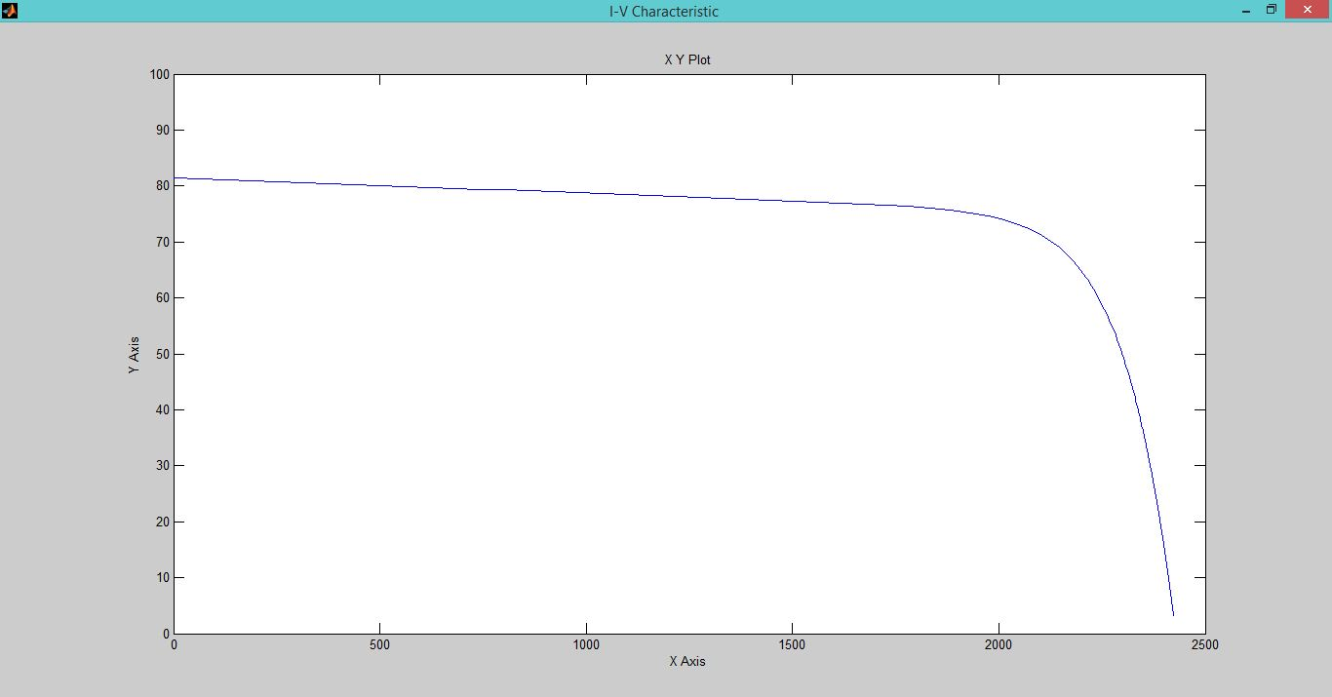
Figure: I-V Characteristic of 150 KWatt SPV System
Figure: P-V Characteristic of 150 KWatt SPV System
The simulation result of 150 KW grid connected SPV system is shown in figure 14 and its peak value of power is shown in figure15
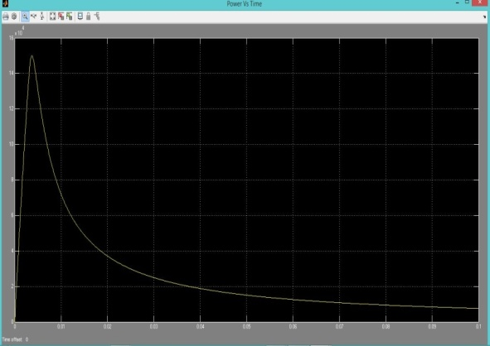
Figure14: Power in KWatt
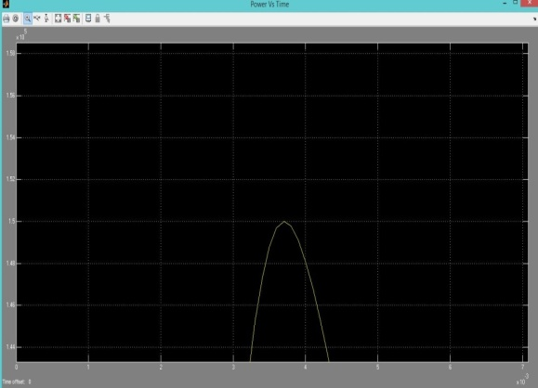
Figure16: Power (KWH) in January 2019
Figure: Power (KWH) in February 2019
Figure: Power (KWH) in March 2019

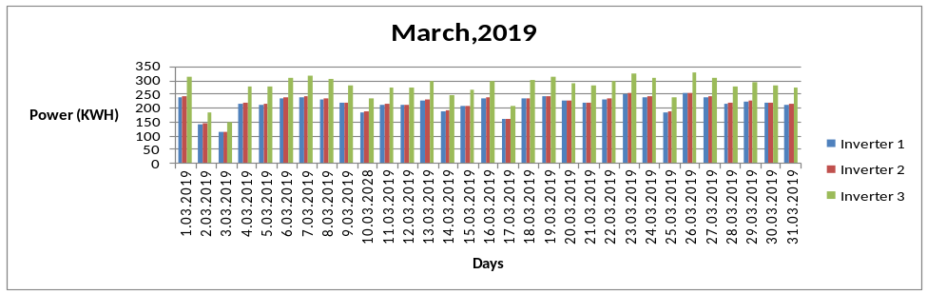
Figure 18: Power (KWH) in March 2019

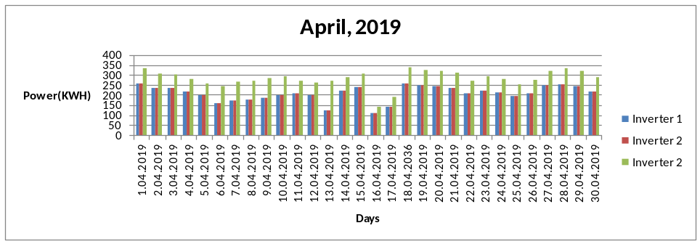
Figure 19: Power (KWH) in April 2019

Figure14: Power in KWatt Figure 15: Peak value of power
150 KW real time data is analyzed from January 2019 to June 2019 and is shown below:

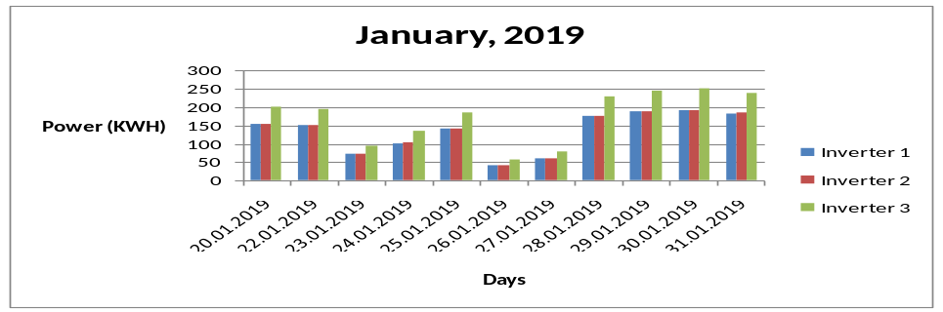
Figure16: Power (KWH) in January 2019
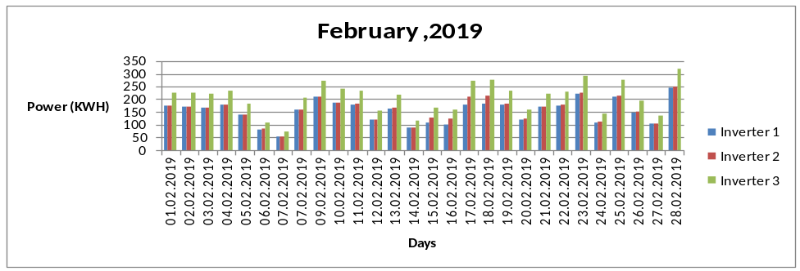
Figure 17: Power (KWH) in February 2019
Figure 18: Power (KWH) in March 2019

Figure 19: Power (KWH) in April 2019

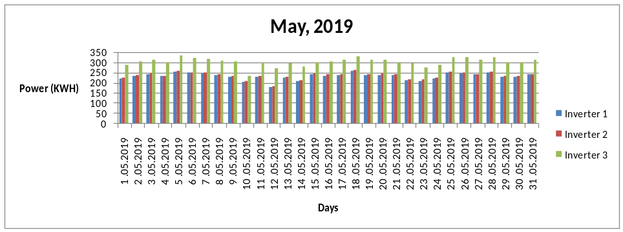

Figure 20: Power (KWH) in May 2019
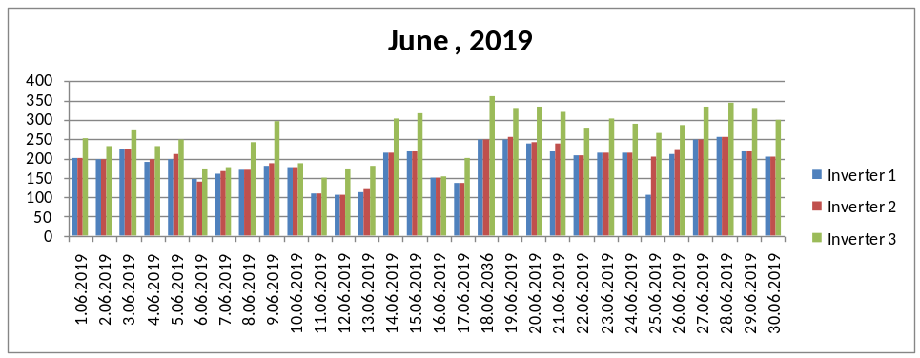
Figure 21: Power (KWH) in June 2019

Conclusion:
We observed that power varies by varying number of modules in series and parallel. In our study we analyzed that using different numbers of series and parallel combination we observed different value power (Theoritical) but simulation value of output power remains same i.e. is 150 K.W. In condition 1 when 21.45(22) and 21.5(22) modules are connected in series and parallel respectively and in condition 2 when 52.8 (53) modules in series and 9 modules in parallel respectively gives 150 KW output power. This shows that in condition 1, one module in series and one module in parallel are 55 % and 50 % partially shaded where as in condition 2, shows that only one module connected in series with 20% partially shaded. Though the number of modules in series and parallel vary output power remains the same. We also observed the percentage error of theoretical power before and after simulation. It is seen that percentage error is very small and is 0.65 % and 0.75 % for condition 1 and condition 2 respectively. From real time data analysis we observed that three inverters are connected to get 150 KW power at the load though different numbers of modules are connected. Number of modules connected to the inverter 1, inverter 2 and inverter 3 are in the ratio of 1:2:4.
Acknowledge
I am thankful to Dr. Mohd Yusuf Yasin and Prof. Mohd Arifuddin Mallick for inspiring me to design the model of Grid connected soar photo-voltaic system and simulate it as simulation on MATLAB/Simulink, in which the simulated results of 150 KW power is obtained as shown in figur14 and 15 respectively. Real time data analysis of 150 KW grid connected SPV system installed on the roof of new girl’s hostelisalso shown. This is gives the idea simulation work and utility of solar power plant. I am thankful to Integral University for registering my manuscript MCN: IU/R&D/2019-MNC 000716. I am also thankful the Institution of Engineer (India), Kolkata, West Bengal, for sanctioning my project title “Performance Analysis of 1 MW Roof Top Grid Connected SPV system using Image Analysis”, R.6/2/DR/2017-18/ RDDR2017015 .

Reference:
Reference to a website:
- Availability of Identified Non-Conventional Resources Of Energy – Their Potential Vis-À-Vis Utilization, Ministry Of New And Renewable Energy, Twenty-Ninth Report Standing Committee on Energy (2011-12), India. http://re.indiaenvironmentportal.org.in/files/file/Availability%20of%20Identified%20Nonconventional%20 Resources%20of%20Energy
- Renewable Power Generation Costs in 2017, International Renewable Energy Agency (IREA) Abu Dhabi. Copyright © IRENA 2018, ISBN 978-92-9260-040-2, https://www.irena.org/-/media/Files/IRENA /Agency/ Publication/2018/Jan/ IRENA_2017_Power_Costs_2018
- Government of India, Ministry of New and Renewable Energy, Physical Progress achievement, https://mnre.gov.in/physical-progress-achievements

Reference to a Journal Publication:

- A.C. Ohajianya et al, Construction of a Solar Panel Using Solar Oven for the Panel Lamination, Advances in Science and Technology, Vol. 9, No. 1&2, September / October, 2015, pp 6 - 13
- Nisha Sharma, modeling, Simulation and Analysis of 100 KW grid connectedPV System using MATLAB/Simulink
- Pratish Rawat et al, Simulation and Performance Analysis of 100 KWp Grid Connected Rooftop Solar Photovoltaic Plant Using PVSYST, International Journal of Science and Research (IJSR) ISSN (Online): 2319-7064
- Tarana Afrin Chandel et al, Performance of Partially Shaded Solar Photovoltaic System, International Journal of Recent Technology and Engineering (IJRTE) ISSN: 2277-3878, Volume-7, Issue-6, March 2019.
- Tarana Afrin Chandel et al, Modeling and Simulation of Photovoltaic Cell using Single Solar Cell and Double Solar Cell Model, International Journal of Innovative Technology and Exploring Engineering, ISSN: 2278-3075, Volume-8 Issue-10, August 2019, pp558-565, Scopus Indexed and UGC Journal

- Basharat Jamil et al, Estimation of solar radiation and optimum tilt angles for south-facing surfaces in Humid Subtropical Climatic Region of India, Engineering Science and Technology, an International Journal 19 (2016) 1826–1835, hosted be Elsevier, https://doi.org/10.1016/j.jestch.2016.10.004
- Solar Electric System Design, Operation and Installation, An Overview for Builders in the U.S. Pacific Northwest, October 2009, © 2009 Washington State University Extension Energy Program, WSUEEP09-013
- GAURAV ARORA et al, International Advanced Research Journal in Science, Engineering and Technology (IARJSET) ,National Conference on Renewable Energy and Environment (NCREE-2015),IMS Engineering College, Ghaziabad Vol. 2, Special Issue 1, May 2015, DOI 10.17148/IARJSET
- NingYi Dai, Multifunctional Voltage Source Inverter for Renewable Energy Integration and Power Quality Conditioning, Hindawi Publishing Corporation, Scientific World Journal, Volume 2014, Article ID 421628, 10 pages, http://dx.doi.org/10.1155/2014/421628
- K Prasada Rao* , Development of A Grid Connected Inverter for Solar PV Systems with Energy Capture Improvement Based On Current Control Strategy, International Journal of Scientific and Research Publications, Volume 3, Issue 4, April 2013 1 ISSN 2250-3153.
- Pratish Rawat and Yashika Rawat Simulation and Performance Analysis of 100 KWp Grid Connected Rooftop Solar Photovoltaic Plant Using PVSYST, International Journal of Science and Research, ISSN: 2319-7064, pp 515-
- Dongmin Xi*, Linjing Hu, Xiaodong Li, Power Grid and Alternating Current Distribution Research of Renewable Energy Generate Electric Power’s Village System, Elsevier Energy Procedia 12 (2011) 328 – 334, ICSGCE 2011: 27–30 September 2011, Chengdu, China
- SOLAR ENERGY GRID INTEGRATION SYSTEMS “SEGIS”, Program Concept Paper October, 2007, Energy efficiency and renewable energy, U S Department of energy
- Solar Energy Grid Integration Systems: Final Report of the Florida Solar Energy Center Team, SAND2012-1395 Unlimited Release Printed March 2012

